Product
Corrective and Preventive Action
Q-0016
Revision B

Revision History
Rev | Status | Date | Author | CO # | Description
A | Draft | 12/3/04 | CB | TBD | Initial Release
A | Draft | 6/5/06 | SB | 04-0009 | Final edits.
B | Draft | 12/22/09 | SB |  | REALLY final edits. Really.

Training
Role | New | Trained in previous rev.
Product CAPA Coordinator | Instructor-led | Not applicable for Rev A
Product CAPA Team | Instructor-led | Not applicable for Rev A
Engineer | Instructor-led | Not applicable for Rev A

Purpose
Product Corrective Actions prevent recurrence of problems; Preventive Actions prevent occurrence of potential problems (including problems detected from trends). Corrections only fix the immediate problem.

MedCommons uses the Mantis system to track defects identified in prototypes and products and their problems’ corrections. The Product Corrective and Preventive Action (CAPA) process evaluates problems to determine whether the problem deserves corrective action. If so, an action plan based on root cause analysis is prioritized and implemented. If appropriate, follow-up monitoring confirms that the action has in fact prevented recurrence of the problem.

Scope
This process applies to problems in development prototypes and released products whether identified by MedCommons or customer personnel. Corrective Actions address actual problems. Preventive actions address potential problems or problems identified based on statistical trends. Usually Product CAPAs result in changes to the product or how it is built and tested, in other words, changes to the Device Master Record. If the root cause of a product problem is in a non-product-specific quality system process, the Product CAPA Team may decide to create a Process CAPA to address that issue. (See Q-0015, Quality System Corrective and Preventive Action.)

Responsibilities

Product CAPA Coordinator
The Product CAPA Coordinator is responsible for maintaining the Product CAPA database, issuing reports, and convening meetings of the Product CAPA Team.

Product CAPA Team
The Product CAPA Team is a named group of engineers and application specialists who review Product CAPAs for evaluation and priority setting.

Engineers
Engineers enter problems that they have identified into Mantis. They may be asked to:
- participate in evaluation of the problem
- correct the problem
- plan or implement actions to prevent recurrence
- monitor to determine if the action has prevented recurrence.

Referenced Documents
Q-0015 Quality System CAPA
Q-0017 Complaint File
Q-0030 Safety Complaints and Mandatory Reporting
Q-0031 Safety Notifications, Field Corrections, and Recalls
QA-0002 Mantis Work Instruction

Definitions
Correction – An action taken to fix an immediate problem.
Corrective Action – An action taken to prevent recurrence of an actual problem.
Preventive Action – An action taken to prevent recurrence of a potential problem.
Complaint – Any written, electronic, or oral communication that alleges deficiencies related to the identity, quality, durability, reliability, safety, effectiveness, or performance of a device after it is released for distribution.

Procedure
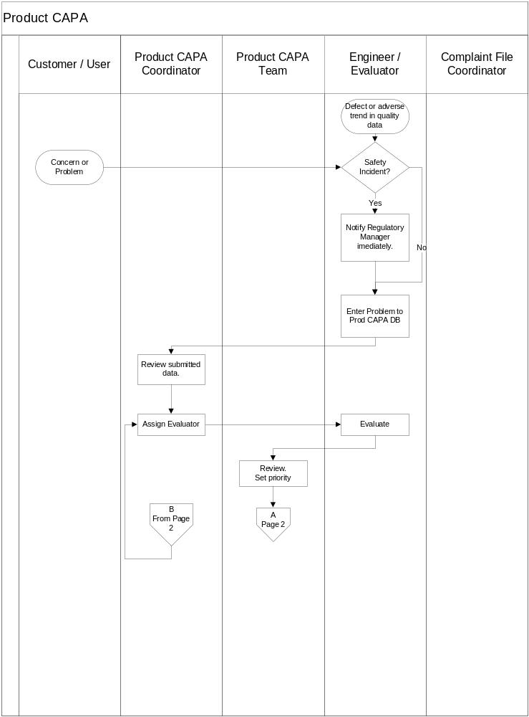
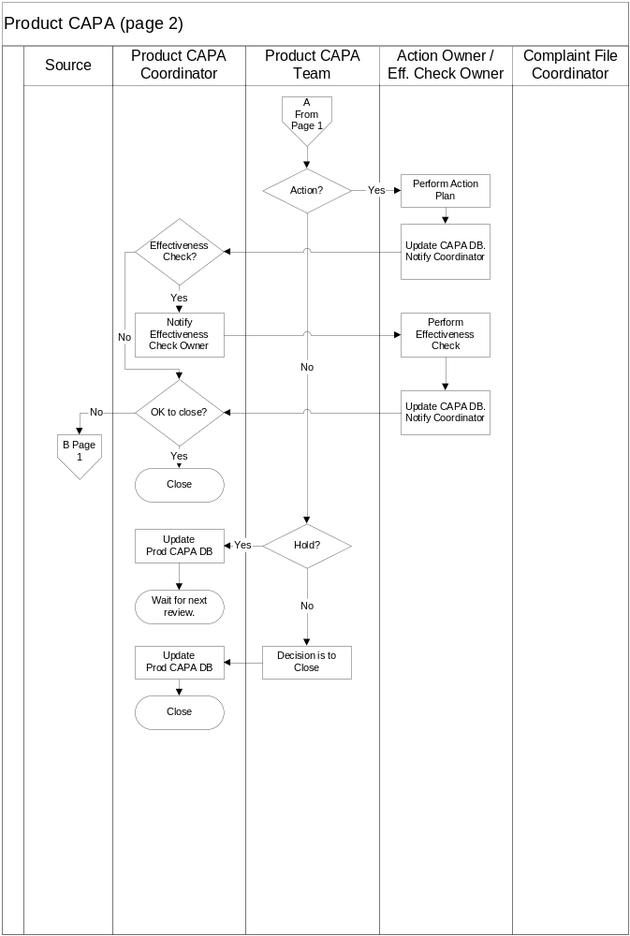

Procedure steps  (from flowchart) | Details
Concern or problem | Concerns appropriate for Product CAPA involve potential defects or feature requests. Engineers may directly find product defects in design testing or from technical information sources, such as component suppliers’ defect alerts. Product and prototype defects are entered into Mantis. Corrections may proceed in advance of a CAPA determination.
Defect or Adverse Trend in Quality Data | Product and prototype defects are trended. Adverse trends should be evaluated as potential CAPAs.
Safety Incident? | A safety incident occurs if a patient, user, or other person has been injured or has died, and the product may have contributed to the injury or death.  A malfunction qualifies as a safety incident if a healthcare professional or other reasonably knowledgeable person states that if the malfunction were to recur, it is likely to cause or contribute to serious injury or death.
Notify Regulatory Manager Immediately | For certain safety incidents, the Quality Manager may need to report the incident to health agencies or clinical trial sites within a short period of time.
Enter Problem to  Prod CAPA DB | The Product CAPA database is located at:  https://www.medcommons.net/mantis/  Enter Summary, Description, and any additional information. Set the CAPA flag (check the box).
Review Submitted Data | The Product CAPA Coordinator reviews the entered and additional information. Is it sufficient to allow an evaluation?
Assign Evaluator | The Product CAPA Coordinator assigns an Evaluator.
Evaluate | The evaluator reviews the entered and additional information. He proposes the:  - Type (defect or enhancement)  - Category (primary area for action)  - Safety risk, performance risk, customer risk  (See appendix A).  - Root cause and Action Plan  (Document in Action Plan field. Indicate location of additional information, if any.)  - Effectiveness Check (or Monitoring)  What activity, if any, is needed after completion of the Action Plan to confirm that the problem is not recurring or is recurring at an acceptable rate?
Review. Set Priority. | The Product CAPA Team reviews the Evaluation. Further evaluation may be required. If the Evaluation is accepted:  - The Action Plan and Effectiveness Check are accepted.  - The Priority is set (1-Critical, 2-High, 3-Medium, 4-Low)  - If the priority is 3 or 4, a decision may be made to take no immediate action and to place the CAPA in Hold status.  - If the priority is 4, a decision may be made to close the CAPA.  - If action will be taken, the status is set Action.
Perform Action Plan | The Action Owner performs (or coordinates the performance of) the Action Plan. (If new issues arise, the Action Owner works with the Product CAPA Coordinator to determine if a new evaluation and action plan are appropriate.)
Update CAPA DB. Notify Coordinator. | When the Action Plan is completed, the Action Owner adds relevant information (or its location) to the Action Plan field in the Product CAPA database, and then notifies the Product CAPA coordinator.
Perform Effectiveness Check | If an Effectiveness Check is indicated, the status is set to Check, and the Effectiveness Check Owner is notified. He performs (or coordinates the performance of) the Effectiveness Check. (If new issues arise, the Effectiveness Check Owner works with the Product CAPA Coordinator to determine if a new evaluation and action plan are appropriate.)
Update CAPA DB. Notify Coordinator. | Upon satisfactory completion of the Effectiveness Check, the Effectiveness Check Owner adds relevant information (or its location) to the Effectiveness Check field.
OK to Close?  Close | If the Product CAPA Coordinator believes there are lingering concerns, he assigns an evaluator to assess the situation. If not, the Coordinator confirms that all information is properly entered or filed, and then sets the status to Closed.
Hold?  Update Prod CAPA DB. | If the Product CAPA Team decides to take no immediate action but place the problem in Hold, the Coordinator confirms that all information is properly entered or filed, and then sets the status to Hold.
Wait for Next Review | The Product CAPA Team from time to time reviews problems in Hold status and may decide to move them to Action or Closed or to keep them in Hold.
Decision is to Close  Update Prod CAPA DB  Close. | If the Product CAPA Team decides to take close a problem without taking action, the Coordinator confirms that all information is properly entered or filed, and then sets the status to Closed.

Appendix A Risk Assessment

Safety Risk | Severity levels:  Negligible – Little or no potential of injury.  Minor – Potential of misdiagnosis or mis-therapy with short duration and minor health impact.  Moderate – Potential of misdiagnosis or mis-therapy with moderate duration or moderate health impact.  Major – Potential of death or serious injury.  Likelihood (Applies to how often harm of the severity level occurs, not to how often the problem occurs.):  Impossible –  Rare – Occurs less than 1% of the time  Occasional – 1%-10% of the time  Frequent – More than 10% of the time
Safety Risk |  | Negligible |  | Minor | Moderate |  |  | Major
Safety Risk | Frequent
Safety Risk | Occasional
Safety Risk | Rare
Safety Risk | Impossible
Safety Risk | Blank =Acceptable |  |  | = ALARP |  |  | = Intolerable

Performance Risk | Severity levels:  Negligible – Unimportant function. Work-around is readily acceptable.  Minor – Unimportant function. Incomplete work-around or annoyance work-around.  Moderate – Important function. Work-around exists, but may be annoying. Or unimportant function with no work-around.  Major – Critical function. Important function with no acceptable work-around.  Likelihood (Applies to how often harm of the severity level occurs, not to how often the problem occurs.):  Impossible –  Rare – Occurs less than 1% of the time  Occasional – 1%-10% of the time  Frequent – More than 10% of the time
Performance Risk |  | Negligible |  | Minor | Moderate |  |  | Major
Performance Risk | Frequent
Performance Risk | Occasional
Performance Risk | Rare
Performance Risk | Impossible
Performance Risk | Blank =Acceptable |  |  | = ALARP |  |  | = Intolerable

Customer Risk | Severity levels:  Negligible – Minor annoyance.  Minor – Non-urgent complaint  Moderate – Urgent complaint  Major – Vehement complaint  Likelihood (Applies to how often harm of the severity level occurs, not to how often the problem occurs.):  Impossible –  Rare – A small number of customers  Occasional – Numerous customers  Frequent – Many customers
Customer Risk |  | Negligible |  | Minor | Moderate |  |  | Major
Customer Risk | Frequent
Customer Risk | Occasional
Customer Risk | Rare
Customer Risk | Impossible
Customer Risk | Blank =Acceptable |  |  | = ALARP |  |  | = Intolerable

